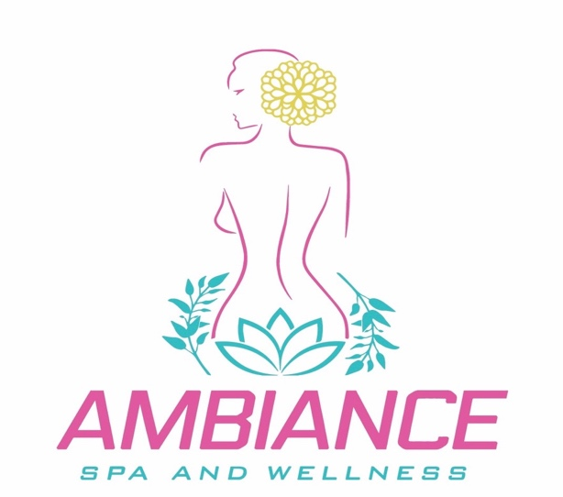
COVID- 19 Pandemic Salon/ Spa treatment Consent form
I,____________________________, knowingly and willingly consent to have salon/ spa service(s) during the COVID-19 pandemic
_______ I understand the COVID-19 virus has a long incubation period during which carries of the virus may not show symptoms and still be highly contagious. It is impossible to determine who has it and who does not, given the current limits in virus testing.
_______ I understand that due to the frequency of visits of other clients and characteristics of the virus, and the characteristics of salon services, that I have elevated risk of contracting the virus simply by being in the spa
______ I confirm that I am not presenting any of the following symptoms of COVID -19 listed below:
• Temperature above 98.7
• Shortness of breath
• Loss of sense of taste or smell
• Dry cough
• Sore throat

_____ I confirm that if I present symptoms between now and my appointment that I will cancel. I also understand that I can be denied services if I show up with symptoms.
_____ I confirm that I have not been around anyone with these symptoms in the past 14 days. _____ I do not live with anyone that sick or quarantined.
_____ To prevent the spread of contagious viruses and to help protect each other, I understand that I will have to follow the spa strict guidelines.
_____ I understand that air travel significantly increases my risk of contracting my risk of contacting and transmitting the COVID-19 virus. And I understand that the CDC, OHSA and Georgia board of Cosmetology and Barbers recommend social distancing of at least 6 feet apart.
_____ I verify that I have not traveled outside the United States in the past 14 days to countries that have been affected by COVID-19
____ I verify that I have not traveled domestically within the United States by commercial airline, bus, or train within the past 14 days

Signature_____________________________________ Date_________________

